NASOLE SHAMIM
23/BIT/BU/R/0023

DIGITAL FORENSICS INVESTIGATION USING AUTOPSY
1. Introduction
Digital forensics is the process of identifying, preserving, analyzing, and presenting digital evidence in a legally acceptable manner. It is widely used in cybercrime investigations, data recovery, and incident response.
Autopsy is an open-source digital forensics tool used to analyze disk images and recover evidence. It provides features such as file system analysis, keyword search, web activity tracking, and timeline reconstruction.
The purpose of this investigation is to analyze a forensic disk image using Autopsy, recover deleted files, examine user activities, and generate a forensic report.

2. Methodology
The investigation followed standard digital forensic procedures:
- Installation and setup of Autopsy
- Creation of a forensic case
- Loading and analysis of disk image evidence
- File system examination
- Recovery of deleted files
- Web activity analysis
- Keyword search
- Timeline reconstruction
- Report generation
All steps were carried out while maintaining data integrity and following ethical guidelines.

3. Task 1: Installation and Setup
Autopsy was downloaded and installed successfully on the system.
Steps:
- Downloaded Autopsy from the official website
- Installed the software using default settings
- Launched Autopsy
- Created a new case
Features of Autopsy:
- File system analysis
- Keyword searching
- Web artifact analysis
- Timeline analysis
- Deleted file recovery
- Report generation

Launching autopsy

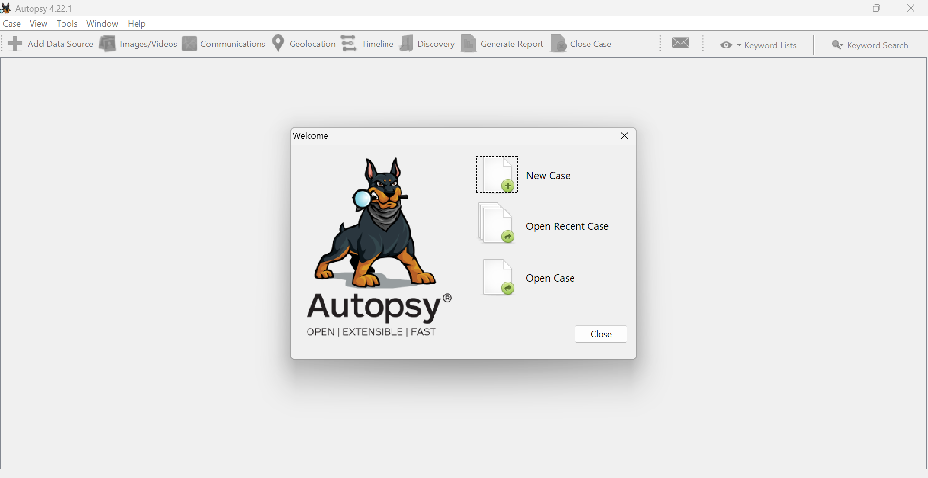
Case creation:
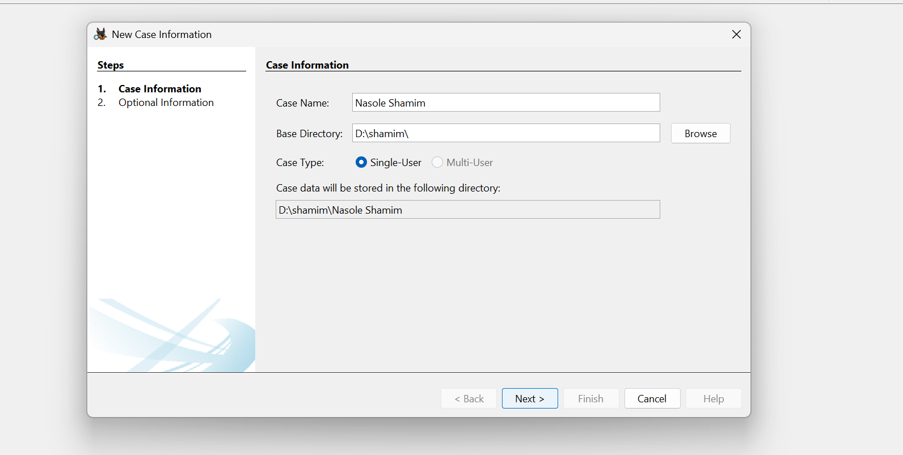
4. Task 2: Case Creation and Evidence Loading
A new case was created in Autopsy and a disk image was loaded.
Steps:
- Selected “Create New Case”
- Entered case name and directory
- Added data source (disk image file)
- Enabled ingest modules
What is a Forensic Image?
A forensic image is an exact bit-by-bit copy of a storage device. It preserves all data, including deleted files, without altering the original evidence.

Case details and evidence loading:
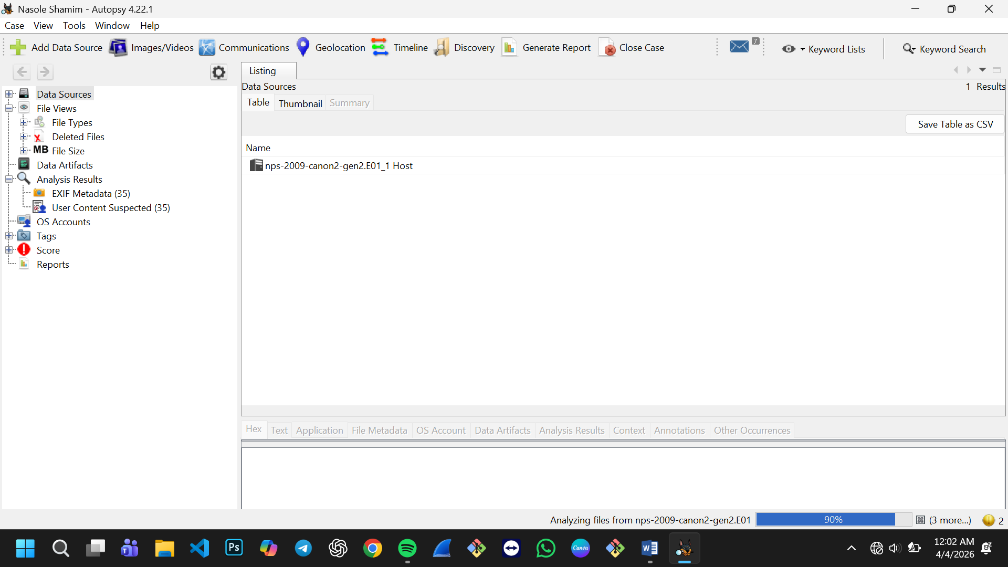

5. Task 3: File System Analysis
The file system was analyzed to identify suspicious and recently accessed files.
Findings:
- Multiple files were examined
- Recently accessed files were identified using timestamps
- Suspicious files included:
- Unusual file names
- Hidden files
- Files with modified timestamps
Analysis:
These files may indicate user activity or attempts to hide data.

File structure view:

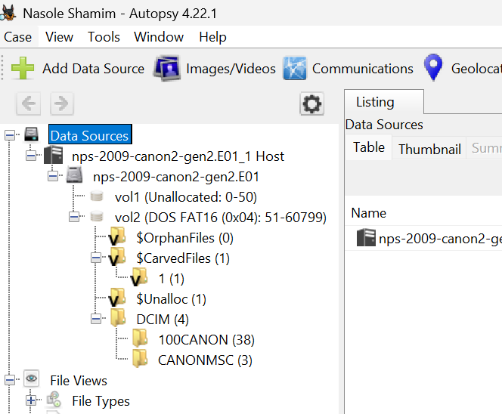

Suspicious items:
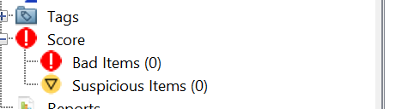
Recently accessed files:
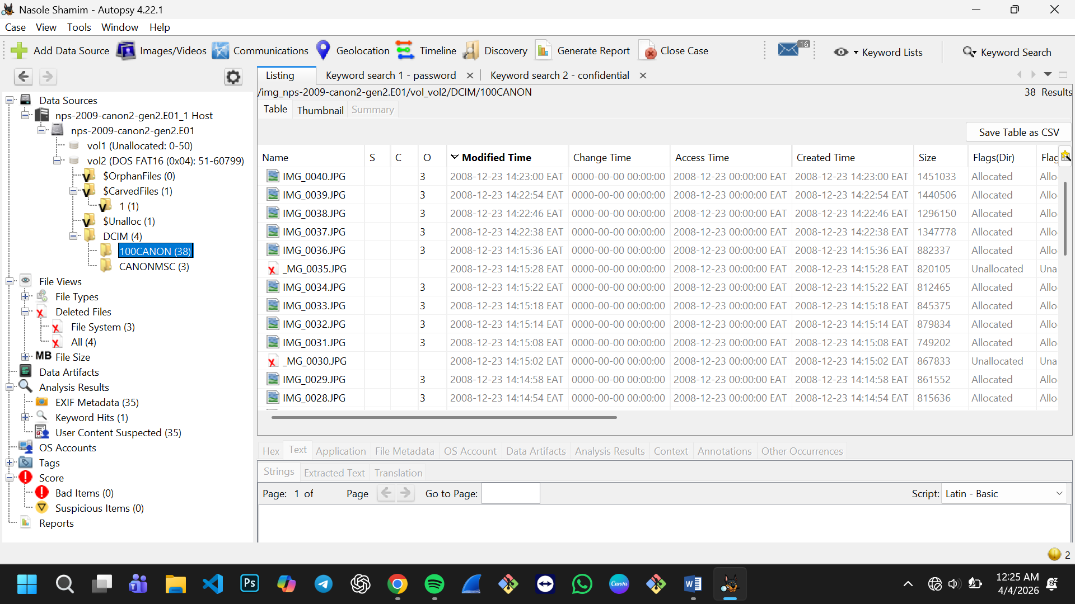
6. Task 4: Recovery of Deleted Files
Autopsy was used to recover deleted files from the disk image.
Relevance:
Recovered files demonstrate that deleted data can still be retrieved and used as evidence.

Deleted files recovery:
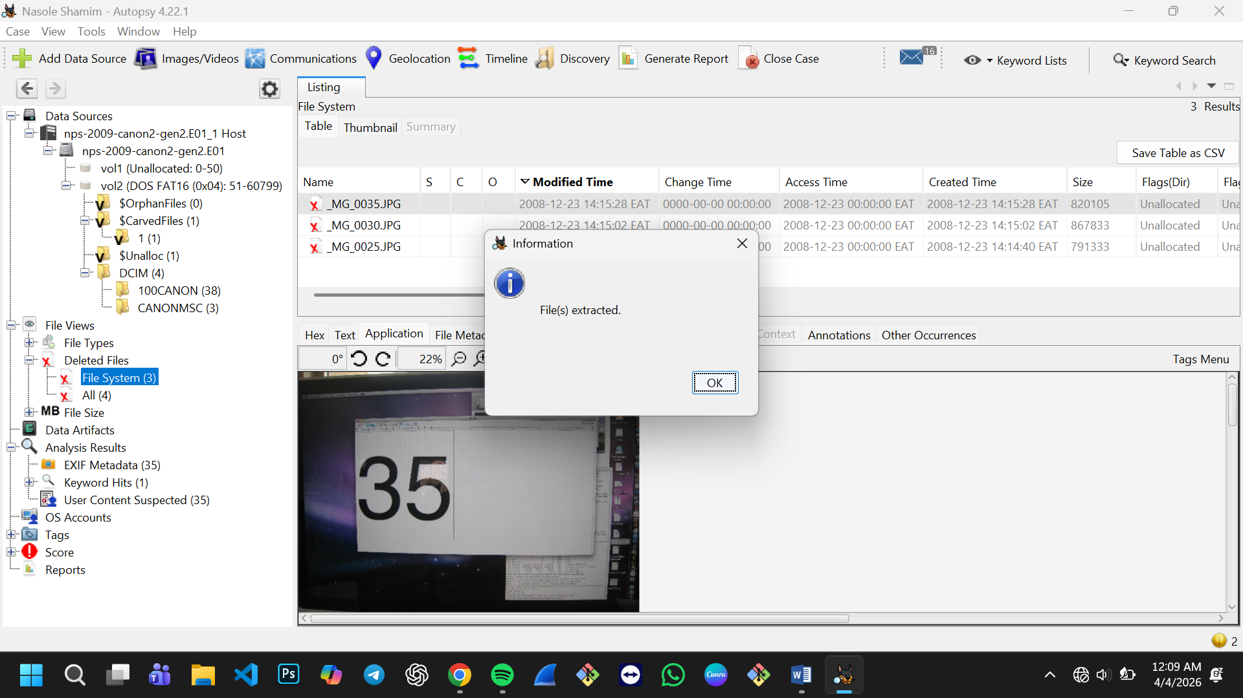
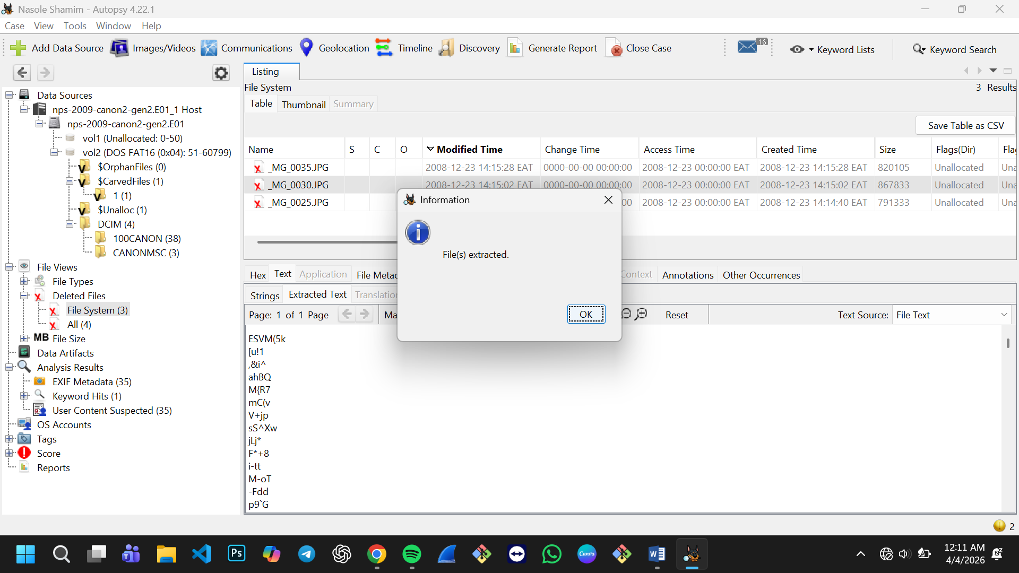
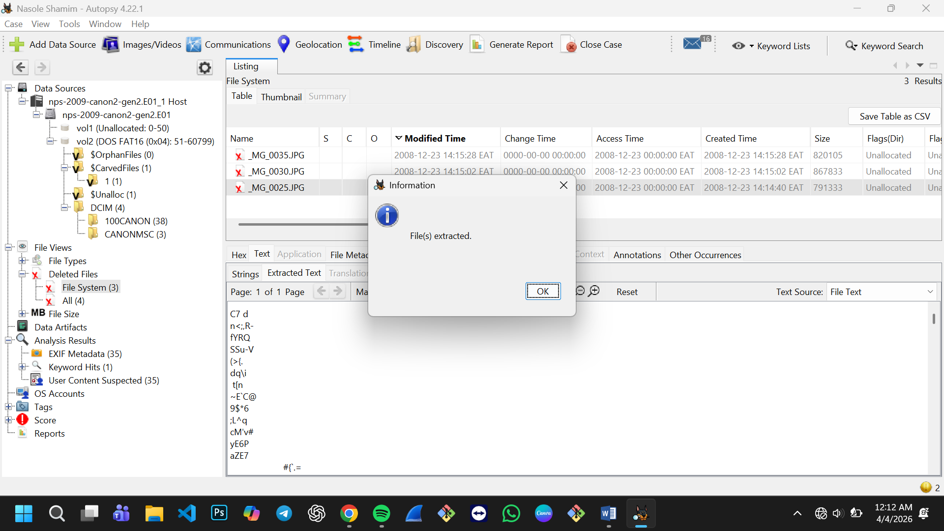

7. Task 5: Web Activity Analysis
No Browser artifacts were analysed since the image was taken by a digital camera.

8. Task 6: Keyword Search and Filtering
Keywords such as “password” and “confidential” were searched.
Findings:
Files containing sensitive keywords weren’t identified.
Analysis:
Keyword searches help quickly locate important evidence within large datasets.
Keyword Search Results:
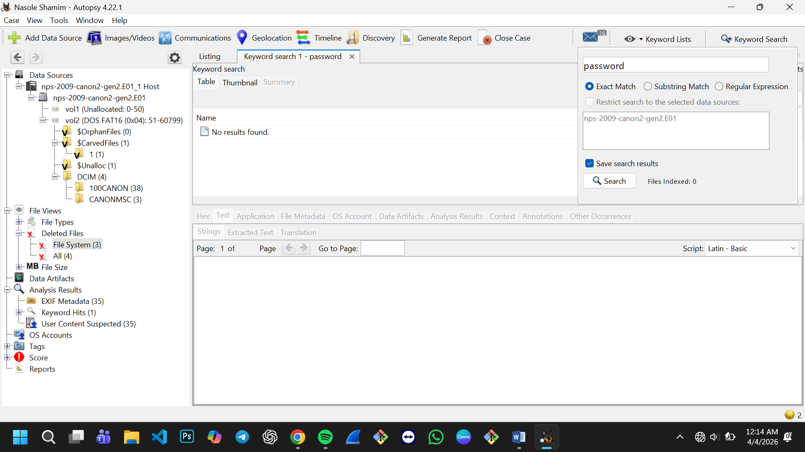
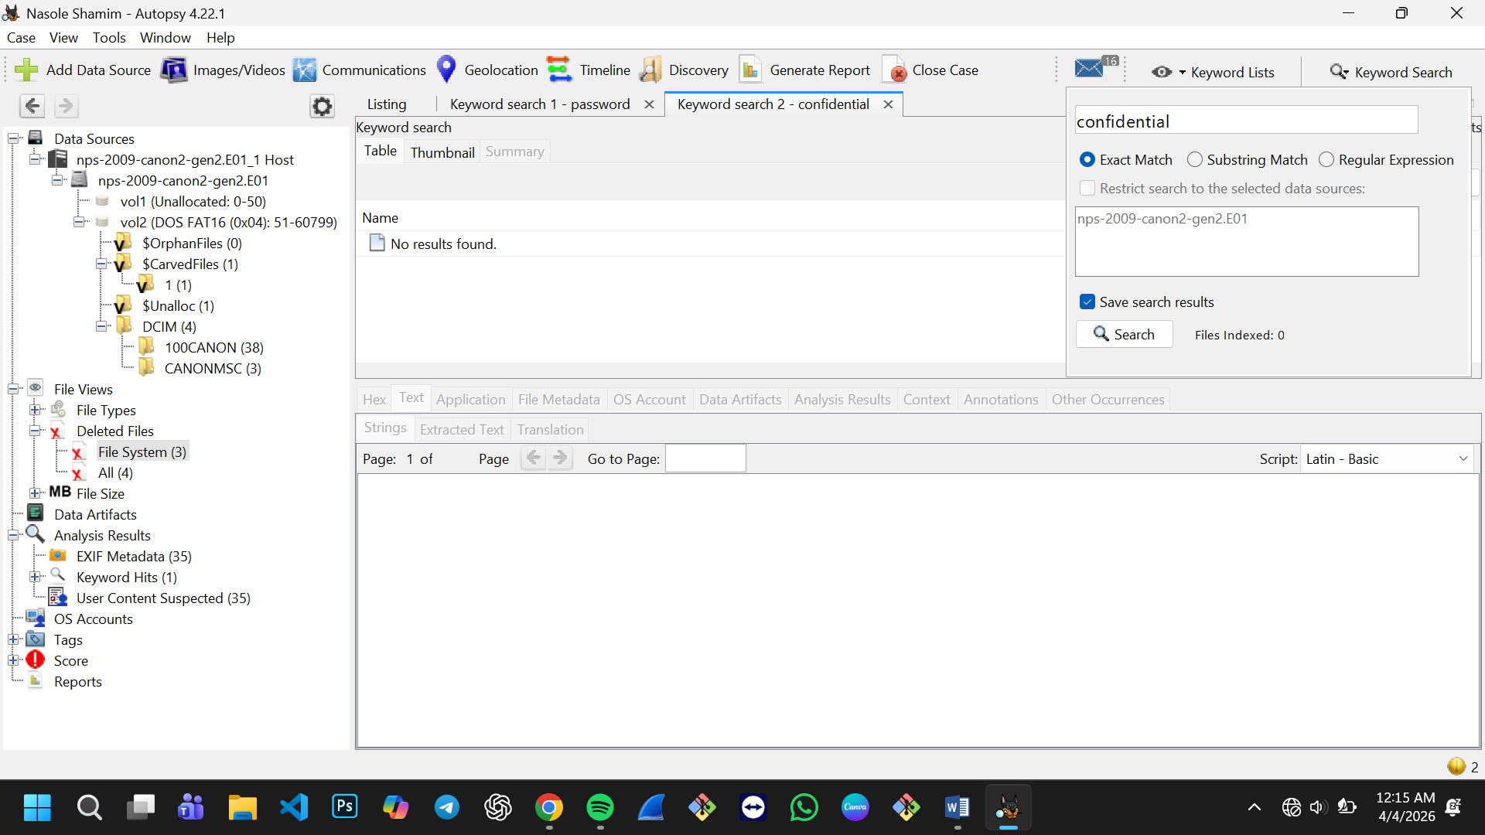

9. Task 7: Timeline Analysis
The timeline feature was used to reconstruct events.
Findings:
File creation, modification, and access times were identified
Sequence of user actions was reconstructed
Analysis:
Timeline analysis provides a clear sequence of events, which is crucial in investigations.
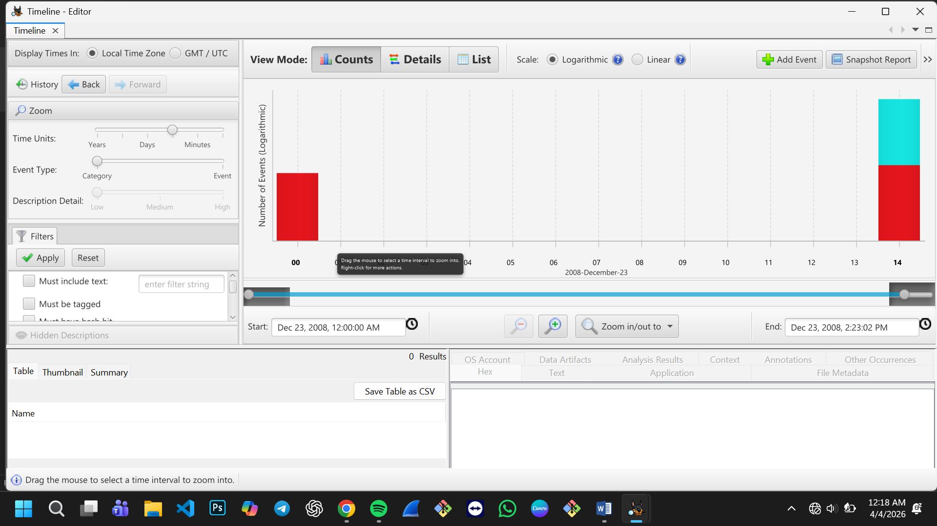

10. Task 8: Reporting
A forensic report was generated using Autopsy.
Steps:
- Selected report generation option
- Chose format (HTML/PDF)
- Exported findings
The report included:
Case details
Evidence summary
Analysis results

Generated report:
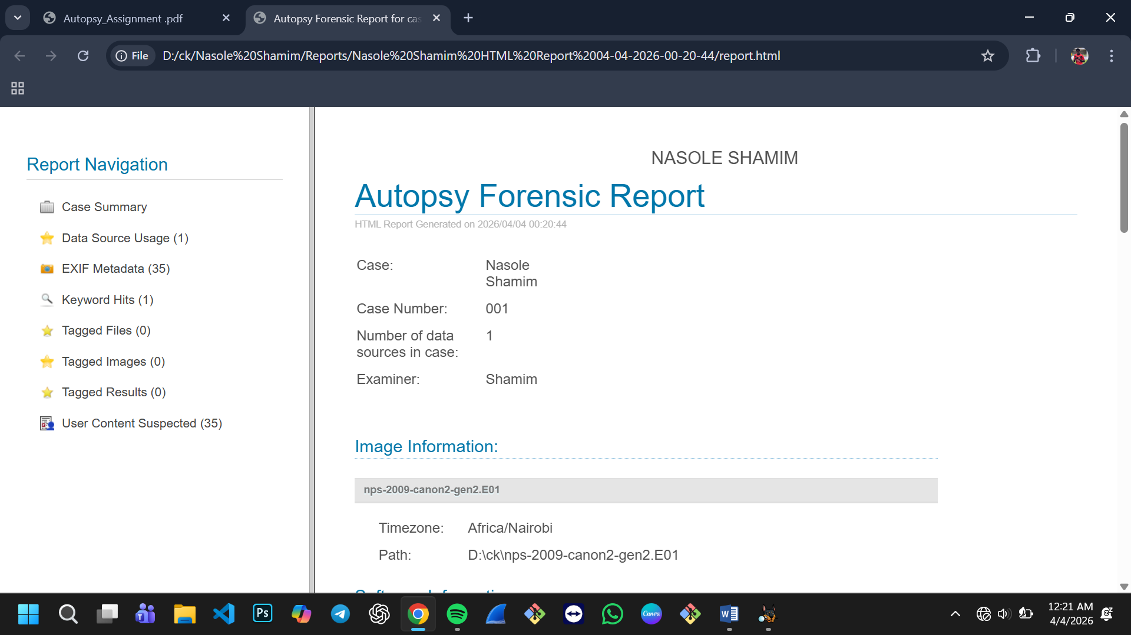

11. Conclusion
This investigation demonstrated how digital forensic tools like Autopsy can be used to analyze disk images, recover deleted files, and examine user activities.
Key outcomes:
- Successfully created and analyzed a forensic case
- Identified suspicious and deleted files
- Recovered important evidence
- Analyzed web activity and user behavior
- Reconstructed event timelines
- Digital forensics plays a critical role in modern investigations, and tools like Autopsy make the process efficient and reliable.
12. Ethical Considerations
Only authorized data was used
No personal or private data was accessed illegally
Data integrity was maintained throughout the investigation

